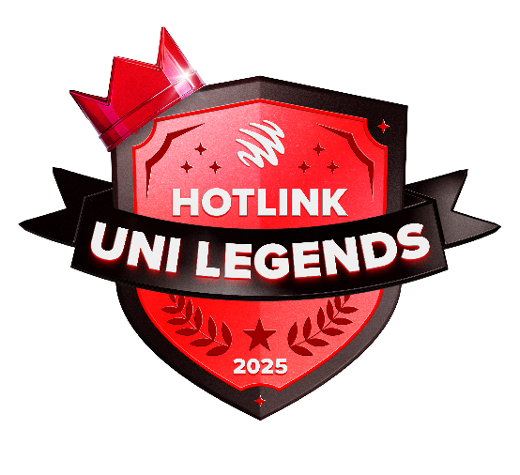
HOTLINK UNI LEGENDS CHALLENGE
This template will guide you through creating a comprehensive event proposal that can receive a full sponsorship by Maxis to bring your campus event ideas to life! Please complete all sections thoroughly to maximize your chances of success.

SUBMISSION GUIDELINES
Complete all sections of this template
- Attach any supporting documents (endorsement letters, detailed program, etc.)
- Submit your proposal to us by 15 July 2025

EVALUATION CRITERIA
Your proposal will be evaluated based on:
- Youth Engagement: Effectiveness in engaging and benefiting students
- Feasibility & Planning: Realistic and well-structured event plan
- Impact & Reach: Potential impact and reach of the event
- Innovation & Creativity: Uniqueness and creativity of the concept
- Relevancy of event to Hotlink’s proposition

PRO TIPS FOR SUCCESS
- Focus on creativity and campus impact to stand out
- Demonstrate how your event leverages technology and connectivity
- Show clear, measurable outcomes
- Highlight how your event creates lasting value for students

Good luck with your proposal!
EVENT OVERVIEW
Event Name
[Insert creative and memorable name]
Event Summary
[Provide a concise summary of your event concept]
Event Objective
[Clearly state what your event aims to achieve, its purpose, and expected outcomes]
Event Date
[Specify dates between Oct to Dec 2025]
Event Duration
[Minimum 1 day; Maximum 5 days]
Event Venue
[Specify location on campus]
Entry Fee for Attendees | RM0 (Free attendance)
Target Attendees
[Describe your target audience - minimum 5,000 participants required]
Event organiser  Name of lead student organiser and contact details | John Doe  +6012 345 6789  johndoe@university.edu.my
Advisor  Name of faculty advisor/ lecturer and contact details | John Doe  +6012 345 6789  johndoe@university.edu.my

EVENT DETAILS
Event Format
[Describe the structure and flow of your event in detail]
Key Activities
[List and describe main activities]
Program Schedule
[Provide a breakdown of what will happen during when]
Unique Selling Points
[What makes your event innovative and special?]

MARKETING & PROMOTION PLAN
Promotional Channels
[Detail which channel you'll use to promote the event]
Marketing Strategy
[Outline your marketing approach]

Marketing Timeline
[When will promotional activities take place?]
Engagement Strategy
[How will you attract and engage your audience?]
IMPACT ASSESSMENT
Expected Outcomes
[Describe tangible and intangible benefits]
Campus Impact
[How will your event positively impact campus life?]

BUDGET BREAKDOWN
Total Budget Requested: RM [Amount]
# | Item | Description  [Explain why each major expense is necessary] | Total Cost (RM)
1
2
3
4
5
6
7
8
9
10

RISK MANAGEMENT
# | Potential Challenges  [Identify possible obstacles] | Contingency Plans  [How will you address these challenges?]
1
2
3
4
5
6

TEAM STRUCTURE
Organizing Committee
[List key team members and their roles]
Faculty Advisor
[Name and contact information of Endorsed Lecturer]

